Example of border boundary conditions
Click here for the previous page
- This example is defined for a 2D geometrical configuration. The size of the domain is
- An inlet is located at the down left side of the domain.
- An outlet is located at the top right side of the domain.
- A symmetrical plan is located at the bottom of the domain (Y=0)
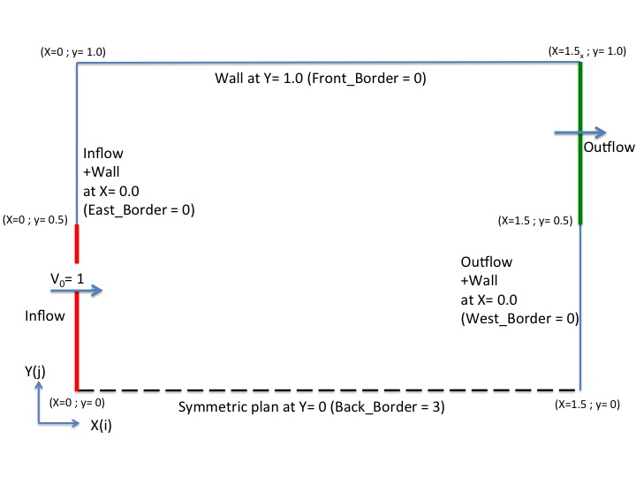
 | - We remind the user the domain is enclosed by default. Wall boundary conditions are implicitly defined at the ends of the domain.  - The inlet and the outlet are built from the namelists Inlet_Boundary_Condition and Outlet_Boundary_Condition, respectively.  These boundary conditions replace the wall boundary conditions (default) over the areas defined in the namelists.  The inlet and outlets boundary conditions are presented herein for the sake of clarity.  - The border boundary condition in accordance with the described configuration are shown just after the inlet/outlet conditions.

Inflow data
- The flow is homogeneous (no multi-species gas)
- Conditions are constant in time
&Inlet_Boundary_Conditions
Type_of_BC= "INLET", Direction_Normal_Plan= 1 ,
Plan_Location_Coordinate= 0.0 ,
Start_Coordinate_of_First_Span = 0.0, End_Coordinate_of_First_Span = 0.5,
Start_Coordinate_of_Second_Span= 0.0 , End_Coordinate_of_Second_Span= 0.0 ,
Flow_Direction= 1 ,
Normal_Velocity_Reference_Value= 1.0 ,
Temperature_Reference_Value= 293.0 ,
Density_Reference_Value= 1.2,
Define_Velocity_profile= 0 /

Outflow data
- The outflow is based on the mass flowrate conservation.
- The normal pressure gradient is zero (Neumann boundary condition).
&Outlet_Boundary_Conditions
Type_of_BC= "OUTLET", Direction_Normal_Plan= 1 ,
Plan_Location_Coordinate= 1.5 ,
Start_Coordinate_of_First_Span = 0.5 , End_Coordinate_of_First_Span = 1.0 ,
Start_Coordinate_of_Second_Span= 0.0 , End_Coordinate_of_Second_Span= 0.0 ,
Flow_Direction= 1 /

Border boundary conditions
- The “BACK” end of the domain must be a symmetric plan.
- The other ends of the domain must be unchanged :
  - WEST : Inlet + Wall (by default West_BC_Name= “None”)
  - EAST : Outlet + Wall (by default East_BC_Name= “None”)
  - FRONT : Wall (the default boundary condition not modified, (by default Front_BC_Name= “None”))
&Border_Domain_Boundary_Conditions Back_BC_Name= "Symmetric" /
Click here for the previous page

