Gauss-Lobatto distribution
Click here to come back to the previous page

Namelist:
&MESH_FUNCTION_DATA Function_Name="GAUSS_LOBATTO" ,
Number_of_Cells= 30 Length= 1.0
Reverse_Ordering= .false. /
Features :

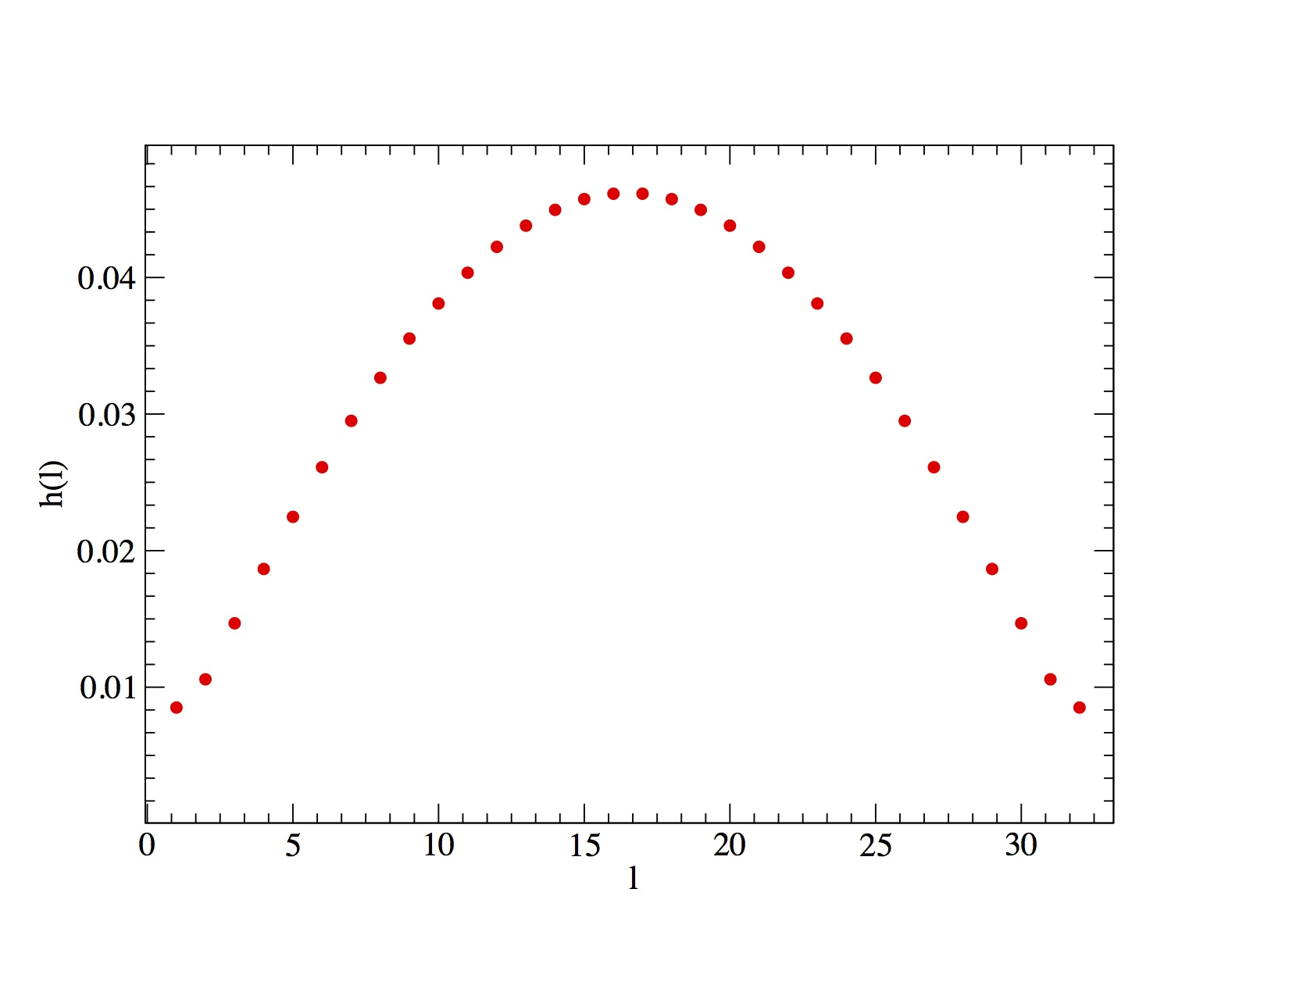
Click here to come back to the previous page

