Hyperbolic tangent function "one side"
Click here to come back to the previous page

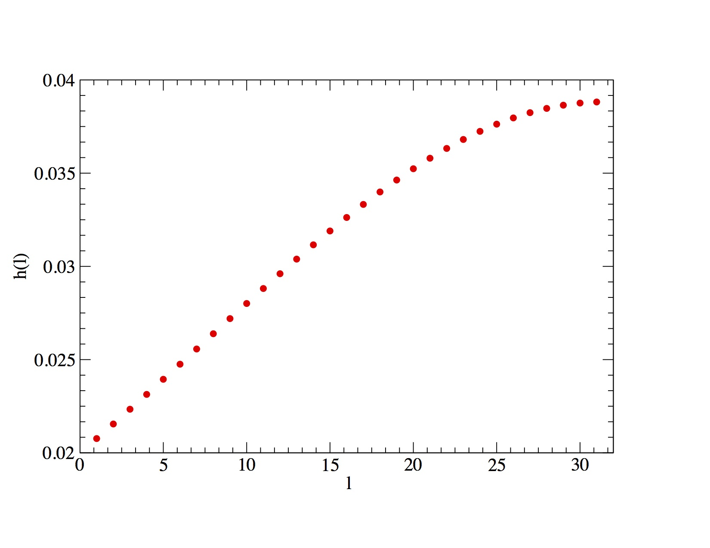
Features :
Monotonic increasing function
est un coefficient fonction du rapport
Click here to come back to the previous page

