Gauss-Lobatto distribution
Click here to come back to the previous page

Description:
Symmetric function with an extremum.
Cell size is refined at left and right tips of the segment.
Namelist:
&MESH_FUNCTION_DATA Function_Name="GAUSS_LOBATTO" ,
Number_of_Cells= 32 Length= 1.0
Reverse_Ordering= .false. /
Cell size distribution h(l) :
is the Length
is the Number_of_Cells
is the coordinate.
is the cell size.
is the cell index.
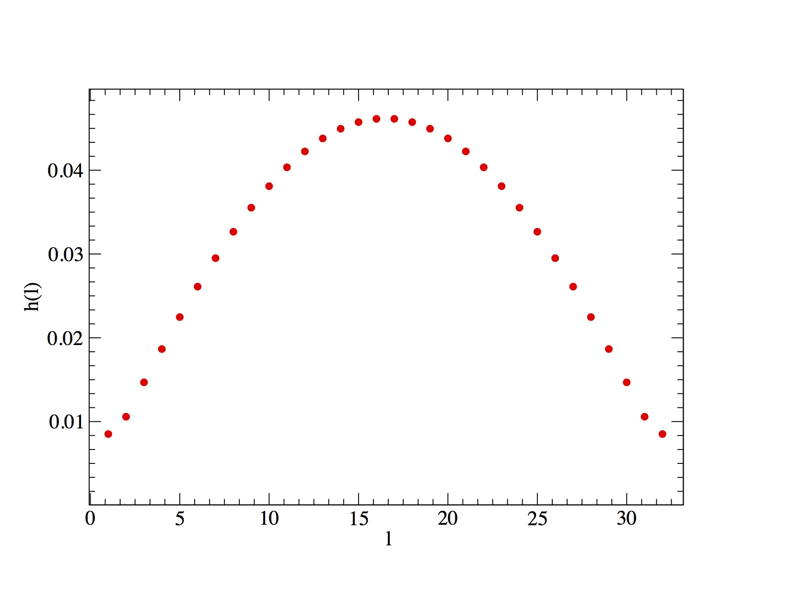
Click here to come back to the previous page

