Namelist "Heat_Wall_Boundary_Condition_Setup"
This data set allows the user to handle the heat boundary conditions applied to walls. Walls are identified according to the orientation of their normal direction from the adjacent fluid-cell. They are named as :
- WEST : if the wall is located at the i-1/2 face-cell (in regard to a fluid-cell)
- EAST : if the wall is located at the i+1/2 face-cell.
- BACK : if the wall is located at the j-1/2 face-cell.
- FRONT : if the wall is located at the j+1/2 face-cell.
- SOUTH : if the wall is located at the k-1/2 face-cell.
- NORTH : if the wall is located at the k+1/2 face-cell.
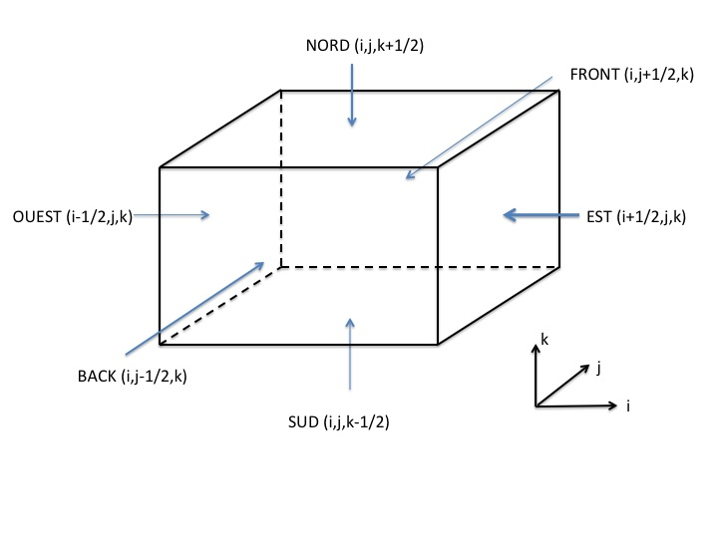
Click on the icon to see the sketch

Full data set of the namelist
&Heat_Wall_Boundary_Condition_Setup
West_Heat_BC_Option = 0 , East_Heat_BC_Option = 0 ,
Back_Heat_BC_Option = 0 , Front_Heat_BC_Option = 0 ,
South_Heat_BC_Option = 0 , North_Heat_BC_Option = 0,
West_Heat_Function_Type = 0 , East_Heat_Function_Type = 0 ,
Back_Heat_Function_Type = 0 , Front_Heat_Function_Type= 0 ,
South_Heat_Function_Type= 0 , North_Heat_Function_Type= 0,
West_Wall_BC_Value = 293. , East_Wall_BC_Value = 293.0 ,
Back_Wall_BC_Value = 293. , Front_Wall_BC_Value = 293. ,
South_Wall_BC_Value = 293. , North_Wall_BC_Value = 293. ,
Material_Thermal_Conductivity= 1.00 ,
Material_Mass_Heat_Capacity = 1.00 ,
Material_Density = 1.00 ,
Time_Fct_Name = "Sinus" ,
Time_Fct_Threshold = 0.0 ,
Time_Fct_Time_Scale = 1.0 ,
Time_Fct_Magnitude = 0.0 ,
End_of_Data_Block = .true. /
 | - Some specific data like thermal conductivity, heat capacity or density, are not directly bounded to thermal boundary conditions, they are used only when the solid body (materialized by walls) is stated like a thermically conductive material and the heat transfer through it is explicitly solved.  - When all the walls of the domain are adiabatic, this namelist could be omitted in the data file. The code uses this boundary condition by default.  - Data related to time evolution can be omitted when the boundary conditions are constant.  - Don't forget to set the boolean data “End_of_Data_Block” at the end of the namelist. A “.true.” value means the end of the data block when several namelists are used to define several type of boundary conditions.  - This namelist can be pooled with other ones of same type (for the velocity components or species mass fraction) to form a wall boundary condition setup.  - When several namelists are present, the first namelist is devoted by default to the walls of the domain's ends (when they exist).  Find here how to construct the wall boundary conditions and some examples.

Definition of the data set

WEST_Heat_BC_Option
- Type : integer value
- Select the type of the heat boundary condition bounded to the WEST wall. The available options are :
  - 0 : Fixed temperature
  - 1 : Fixed heat flux
  - 2 : Heat transfer in the solid body is explicitly calculated. The solid boby is thus stated like a thermically conductive material and the heat transfer through it is explicitly solved.
  - 3 : Time-variable heat flux. Time functions defined further are required in the data set.
  - 4 : Time-variable temperature. Time functions defined further are required in the data set.
- Default value= 1

WEST_Heat_Function_Type
- Type : integer value
- Definition of the distribution law over the wall face. The available options are :
  - 0 : Uniform distribution over the wall
  - greater than 0 : require an user's defined function in the module module_user_define_wall_bc.f90)
Default value= 0

WEST_Wall_BC_Value
- Type : real value
- Reference value of the temperature or the heat flux on the wall. This depends on the type of boundary condition chosen (see WEST_Heat_BC_Option)
- Default value= 0.0
NOTE : The equivalent data exist for the other walls. Please, replace the characters “WEST” by “EAST”, “FRONT”, “BACK”, “NORTH or “SOUTH” to define the boundary conditions on the walls oriented to the appropriate direction.

The following data are useful for the thermically conductive materials (materialized by walls) in which the heat transfer is explicitly solved, otherwise they can be omitted.

Material_Thermal_Conductivity
- Type : real value
- Thermal conductivity of the solid body
- Default value= Thermal conductivity of the fluid

Material_Mass_Heat_Capacity
- Type : real value
- Mass heat capacity of the solid body
- Default Value= Heat capacity of the fluid.

Material_Density
- Type : real value
- Density of the solid body
- Default value = Density of the fluid

The following data are useful when the heat boundary conditions are time variable. Otherwise they can be omitted.

Time_Fct_Name
- Type : character string bounded to the user's time function defined in the module “module_user_define_temporal_function.f90”. The time functions already available are :
  - “Sinus” : sinus function
  - “Linear_Ramp” : Linear ramp function

Time_Fct_Threshold
- Type : real value
- Time from which the time function is enabled

Time_Fct_Time_Scale
- Type : real value
- Time scale of the function (i.e the period for a sinusoidal function)

Time_Fct_Magnitude
- Type : real value
- Magnitude of the time function

End_of_Data_Block
- Type : boolean value
- Specify the end of the namelist or a group of this type of namelist used to define different types of heat boundary conditions.

