Example of inflow/outflow boundary conditions
- This example is defined for a 2D geometrical configuration. The size of the domain is
- The flow is homogeneous (no multi-species gas)
- An inlet is located at the down left side of the domain.
- An outlet is located at the top right side of the domain.
- Conditions are constant in time
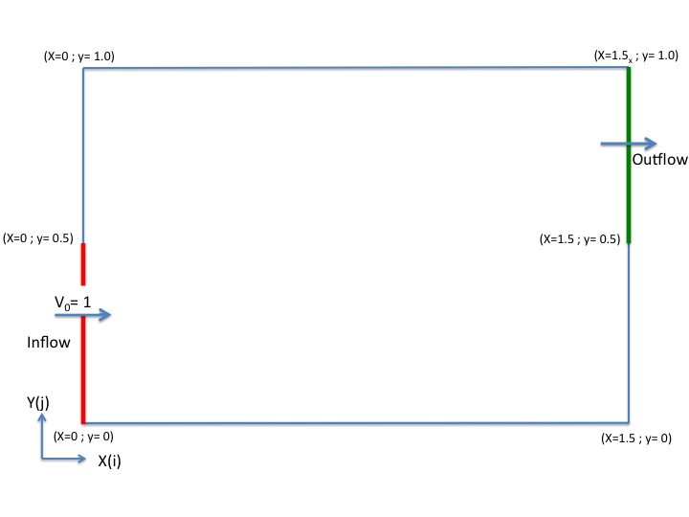

Inflow data

Example 1
- The flow is homogeneous (no multi-species gas)
- Conditions are constant in time
&Inlet_Boundary_Conditions
Type_of_BC= "INLET", Direction_Normal_Plan= 1 ,
Plan_Location_Coordinate= 0.0 ,
Start_Coordinate_of_First_Span = 0.0, End_Coordinate_of_First_Span = 0.5,
Start_Coordinate_of_Second_Span= 0.0 , End_Coordinate_of_Second_Span= 0.0 ,
Flow_Direction= 1 ,
Normal_Velocity_Reference_Value= 1.0 ,
Temperature_Reference_Value= 293.0 ,
Density_Reference_Value= 1.2,
Define_Velocity_profile= 0 ,
End_of_Data_Block= .true. /

Example 2
Not for the release SUNFLUIDH_EDU
- The flow is homogeneous (no multi-species gas)
- The temperature and the density are constant.
- The normal velocity component is time-dependent :
  - The function is sinusoidal. The mean value of the time function is given by “Normal_Velocity_Reference_Value”.
  - the frequency is 10 Hz
  - The magnitude is 40% of the mean inlet velocity
&Inlet_Boundary_Conditions
Type_of_BC= "INLET", Direction_Normal_Plan= 1 ,
Plan_Location_Coordinate= 0.0 ,
Start_Coordinate_of_First_Span = 0.0, End_Coordinate_of_First_Span = 0.5,
Start_Coordinate_of_Second_Span= 0.0 , End_Coordinate_of_Second_Span= 0.0 ,
Flow_Direction= 1 ,
Normal_Velocity_Reference_Value= 1.0 ,
Temperature_Reference_Value= 293.0 ,
Density_Reference_Value= 1.2,
Define_Velocity_profile= 0 ,
Time_Fct_Name= "Sinus" , Time_Fct_Threshold= 0.0 ,
Time_Fct_Time_Scale= 0.1 , Time_Fct_Magnitude= 0.4 ,
End_of_Data_Block= .true. /

Outflow data

Example 1
- The outflow is based on the mass flowrate conservation.
- The normal pressure gradient is zero (Neumann boundary condition).
&Outlet_Boundary_Conditions
Type_of_BC= "OUTLET", Direction_Normal_Plan= 1 ,
Plan_Location_Coordinate= 1.5 ,
Start_Coordinate_of_First_Span = 0.5 , End_Coordinate_of_First_Span = 1.0 ,
Start_Coordinate_of_Second_Span= 0.0 , End_Coordinate_of_Second_Span= 0.0 ,
Flow_Direction= 1 ,
End_of_Data_Block= .true. /

Example 2
Not for the release SUNFLUISH_EDU
- The outflow is based on pressure conditions.
- The (dynamic) pressure value is given by “Pressure_Reference_Value”. It is imposed out of the domain and located at a distance “Length_Scale” from the outflow plan (Robin condition).
- Keep in mind that the pressure is here related to the dynamics, not to the thermodynamics of the flow. It is therefore defined from a reference value which can be null.
&Outlet_Boundary_Conditions
Type_of_BC= "FREEBC", Direction_Normal_Plan= 1 ,
Plan_Location_Coordinate= 1.5 ,
Start_Coordinate_of_First_Span = 0.5 , End_Coordinate_of_First_Span = 1.0 ,
Start_Coordinate_of_Second_Span= 0.0 , End_Coordinate_of_Second_Span= 0.0 ,
Flow_Direction= 1 ,
Pressure_Reference_Value = 0.0 , Length_Scale= 0.2 ,
End_of_Data_Block= .true. /

