Hyperbolic tangent function "one side"
Click here to come back to the previous page

Description:
Monotonic increasing function.
Cell size refined at the left tip of the segment.
Namelist :
&MESH_FUNCTION_DATA Function_Name="TANH_ONE_SIDE" ,
Number_of_Cells= 32 ,
Length= 1.0 ,
Left_Cell_Size= 1.0d-03 ,
Reverse_Ordering= .false. /
Cell size distribution h(l) :
is the Length.
is the Number_of_Cells.
is the Left_Cell_Size.
is the cell size.
is the cell index
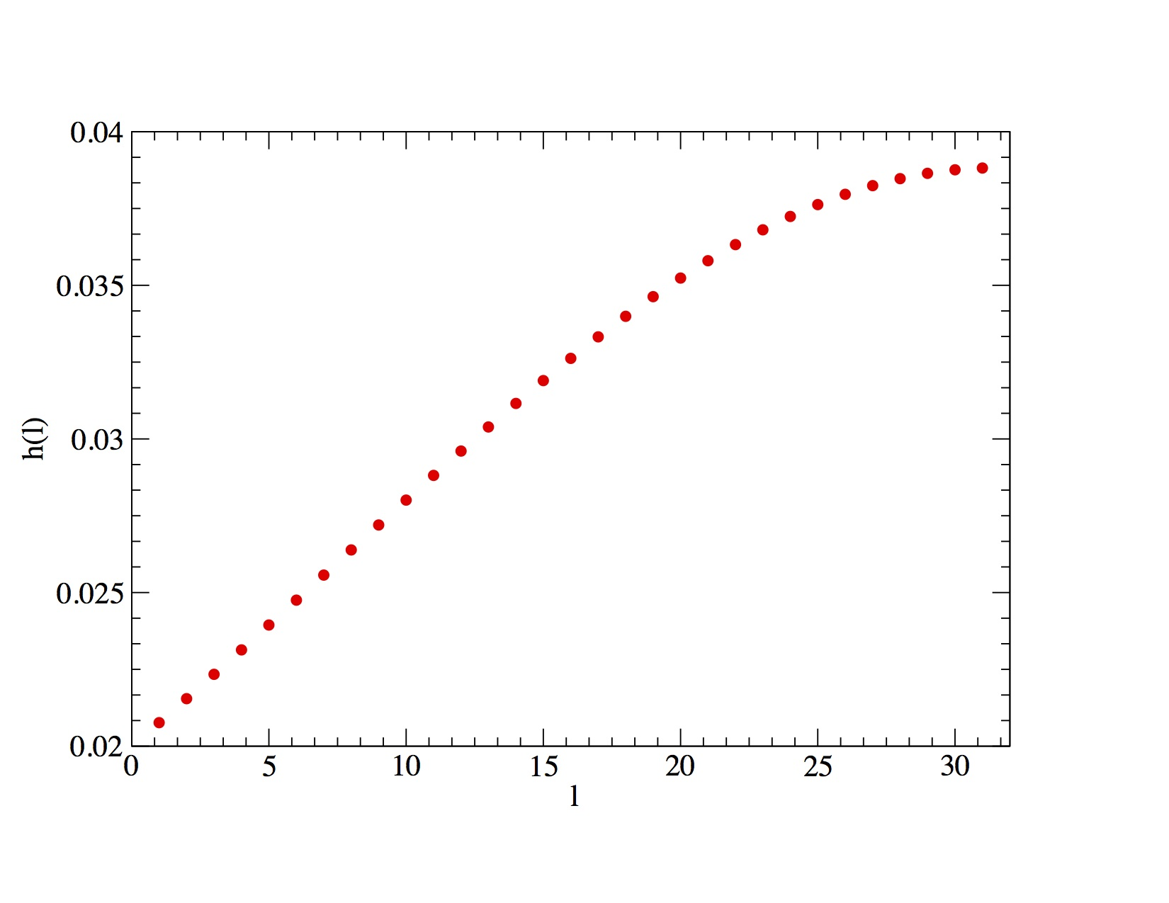
Click here to come back to the previous page

