Hyperbolic tangent function "two side"
Click here to come back to the previous page

Description:
Function with an extremum.
Cell size is refined at left and right tips of the segment.
Namelist :
&MESH_FUNCTION_DATA Function_Name="TANH_TWO_SIDES" ,
Number_of_Cells= 32 ,
Length= 1.0 ,
Left_Cell_Size= 2.0d-02 ,
Right_Cell_Size= 3.0d-02 ,
Reverse_Ordering= .false. /
Cell size distribution h(l) :
is the Length.
is the Number_of_Cells}.
is function of Left_Cell_Size and Right_Cell_Size.
is the coordinate.
is the cell size.
is the cell index.
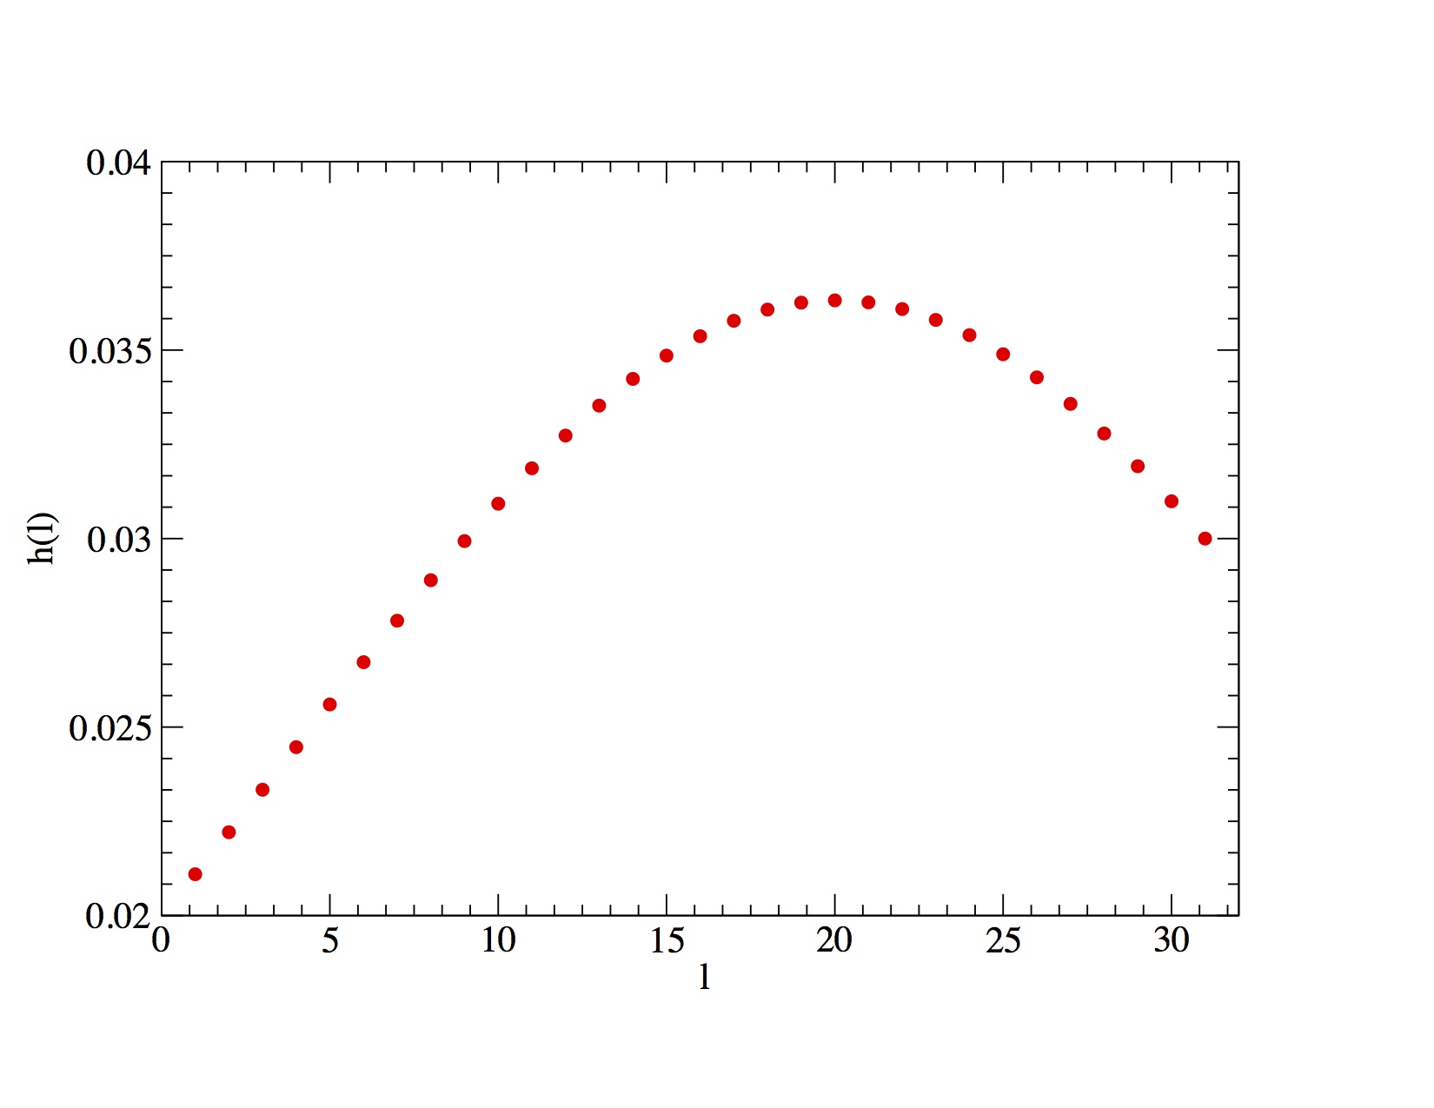
Click here to come back to the previous page

